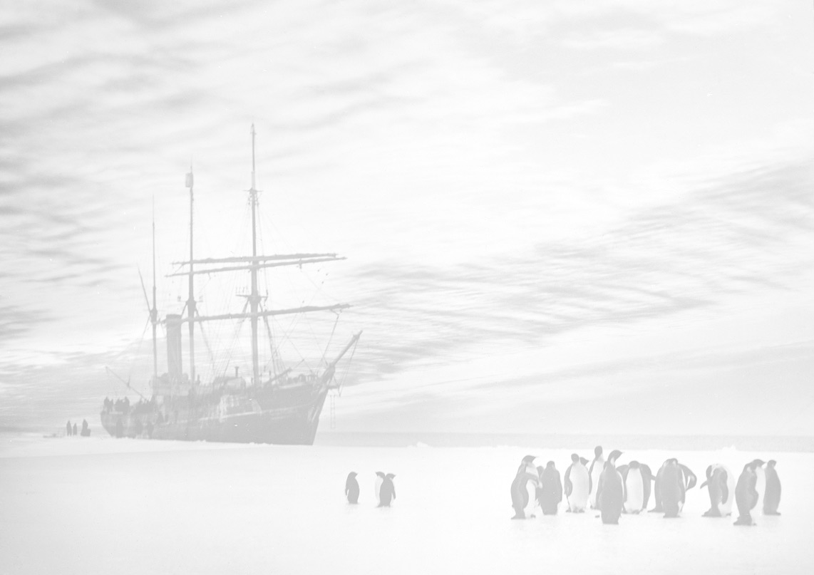Antarctic Leadership
Achievements and Legacies from the Heroic Age
Lesson Plan
Read through the PowerPoint presentation about the 4 explorers and fill in the table:
 | Roald Amundsen | Douglas Mawson | Robert  Scott | Ernest Shackleton
Age at most famous expedition
Most famous expedition

Age when died

2 ways he is remembered today

What was his main job?

How many times did he go to the Antarctic?
What did he do after his last Antarctic expedition?

You are going to prepare a short presentation* of about five minutes about one of these explorers presenting the case for why his achievements and legacy were the most important.
*You may or may not be called on to present it to the class, it will need to be written regardless.
Antarctic Leadership
Achievements and Legacies from the Heroic Age
Lesson Plan
Read through the PowerPoint presentation about the 4 explorers and fill in the table:
 | Roald Amundsen | Douglas Mawson | Robert  Scott | Ernest Shackleton
Age at most famous expedition
Most famous expedition

Age when died

2 ways he is remembered today

What was his main job?

How many times did he go to the Antarctic?
What did he do after his last Antarctic expedition?

You are going to prepare a short presentation* of about five minutes about one of these explorers presenting the case for why his achievements and legacy were the most important.
*You may or may not be called on to present it to the class, it will need to be written regardless.

